Unit 1: hello
- Loại từ khác nhóm.
- a. Mai | b. Nga | c. Hi
- a. Hi | b. Bye | c. Hello
- a. I’m | b. I | c. I am
- a. Helol | b. Hello | c. Holle
- a. Hello, I’m Mai | b. Hi, Mai | c. Hi, I’m Mai
- Khoanh vào chữ cái thừa trong từ.
- Heello a. l b. e c. o
- Hai a. a b. H c. i
- I’am a. a b. m c. I
- Điền từ thích hợp điền vào chỗ trống.
Hello Bye I Nam Mai

- _________, I’m Mai.
- Hi, ___________. ____’m Nam
- Goodbye, ________.
- ________, Mai.
- Đánh số để tạo thành hội thoại.
NGA
Bye, Phong.
Hello, I’m Nga.
PHONG
Hi, Nga. I’m Phong.
Goodbye, Nga,
- Luyện viết.
Hello …………….. ……………… ……………… ……………… …………….
Hi ………. ………. ……………. ………… …………. ………… …………

UNIT 2 : WHAT’S YOUR NAME?

Bài tập 1 : Dịch các từ/ cụm từ sau sang tiếng Anh :
- Của tớ (của tôi) :
- Của bạn :
- Của cô ấy
- Của anh ấy
- Tên
- Là
- Gì/ cái gì ?
- Như thế nào
- Đánh vần
- Gặp
Bài tập 2 : Dịch đoạn hội thoại sau sang tiếng Anh
Peter : Xin chào, tên của tớ là Peter.

Quân : Chào Peter. Tên của tớ là Quân.

Peter : Rất vui khi được gặp bạn, Quân. Bạn đánh vần tên của mình như thế nào ?

Quân : Q - U - Â – N.

Linda : Tên của bạn là gì ?

Phong : Tên của tớ là Phong . Còn bạn tên là gì ?

Linda : Tên tớ là Linda. L – I – N – D – A .

Bài tập 3 : Hoàn thành các câu sau đây
- This _ _ my school.
- What’s _ _ _ _ name ?
- How _ _ _ you ?
- Hi, Tony. I _ _ Laura.
- Nice to m _ et you.
- Hi, _ _ _ is Peter.
- Hi, _ _ name is Phong.
- I am _ _ _ _, thank you.
- My _ _ _ _ is Mary.
- Nice _ _ meet you.
UNIT 3. THIS IS TONY
(Test 1)
Ex 1: Complete each word ( - hoàn thành từ)
1. _ello 2. _es 3. _ _is 4.Th_nks
5. _ony 6. _ _ey 7. _inda 8. _ame

Ex 2: Reoder the letters : (Sắp xếp các chữ cái thành từ có nghĩa)
a. dooeybg =..................... b. slpel =...................... c.mena=.................... d. kahnst =..............

Ex 3: Circle A , B or C. Write the correct word on the line.(Khoanh đáp án đúng)
1.............is Peter. 2. The girl is Mai.............is my friend.
A. I B. She C. He A. He B. They C.She
3. Hi.My.............is Tony. 4................. I’m Linda.
A. How B. name C. Fine A. Hello B. Goodbye C. Am

Ex 4: Match sentences( Nối)
1. Hi.I’m Mai. A. Hi,Nga.I’m Tony.
2. Hello.I’m Nga. B. Bye.See you later.
3. How are you? C. Hello.I’m Hoa.
4. Goodbye. D.Fine, thanks.

Ex 5:Circle the correct sentencs (khoanh đáp án đúng)
1. Is this Linda?
A: Yes, she is.
B: No, she not is. 2. Is that Mary?
A: Yes, she is.
B: Yes, he is
3. Is Peter your friend?
A. Yes, he is.
B. Yes, she is. 4. Is Tony your friend?
A. yes, she is.
B. No, he isn’t.

Ex 6:Read and complete (Hoàn thành đoạn họi thoại với các từ trong hộp)
She Mary No friend And thanhs fine How
1. A: Is that(1) .....................? 2. A: Hi,Mai. (5) ...................are you?
B: Yes, (2).....................is. B: I’m (6) ...................Thank you.(7) ...............you?
A: Is she your (3)..................? A: Fine. (8)........................
B: (4) ....................., she isn’t.

Ex 7:Reorder the words to the complete sentence. (sắp xếp các từ thành câu có nghĩa)
1. am/ I/ Lili/. →
2. to/ you/ nice/meet/. →
3. 3.my/ Peter/is/name/. →
4. your/ what/ is/ name/?/ →
5. Lan/ she/ is/?/ →
6. is /friend/ he/my/. →
7. my/ is/ friend/Mary/. →
8. Mai/ too/ friend/ is/ my/. →
Hä vµ tªn: .....................................................................
UNIT 4. HOW OLD ARE YOU?
(Test 1)
I. Hoµn thµnh c¸c c©u sau.
1. ......ell......, Alan.
2. What’s yo......r name?
3. H......w a......e y......u?
4. I am ...... ......ne. Tha......k you.
5. S...... ...... you l......t......r.
II. H·y viÕt c¸c sè sau b»ng ch÷.
1. .................. 2. .................. 3. .................. 4. .................. 5. ..................
6. .................. 7. .................. 8. .................. 9. .................. 10. ..................
III. H·y viÕt c¸c kÕt qu¶ cña c¸c bµi to¸n sau b»ng ch÷.
- six + two = ........................ 2. ten – five = ...........................
- one + three = ..................... 4. (nine + ten) – eight = ..................
- (eight + seven) – nine = ..................... 6. (two + four) – five = .....................
IV. H·y xÕp c¸c c©u sau thµnh 1 bµi héi tho¹i hîp lý.
- I’m fine, thank you! And you?  - Hi, Tram. How are you?  - I’m fine, thank! This is Thuy. She is my friend.  - Hello, Thang.  - Good morning, Tram. Nice to meet you, too.  - Good morning, Thuy. Nice to meet you. | - ….  - ….  - ….  - ….  - ….  - ….
V. Hãy viết đáp án bằng chữ:
- 2 + 5 + 10 = |  | - 5 + 5 + 5 + 5 =
- 20 - 12 + 3 = |  | - 3 + 11 + 7 – 11 =
- 7 + 8 = |  | - 6 + 6 + 3 =
- 9 – 8 + 9 = |  | - 17 + 2 =
- 10 + 10 – 13 = |  | - 14 – 4 + 3 =
VI. H·y ®iÒn tõ thÝch hîp vµo chç trèng.
  - ............... is she? - She ............... ............... friend.
  - .................. morning.
  - Nice ......... meet ................
  - How.................. are.................. ?
VII. Hãy dịch các câu sau sang tiếng Anh.
- Cô ấy tên là gì?
- Cô ấy bao nhiêu tuổi?
- Tên của cô ấy là Hoa.
- Cô ấy 8 tuổi.
- Kia là Tuấn.
- Anh ấy 10 tuổi.

UNIT 1: HELLO
- Complete and say aloud: B H
a. ......ello b. .......ye
- Read and match:
- Hello |  | - are you?
- Hi, |  | - thanks.
- How |  | - I’m Nam.
- I’m fine, |  | - to meet you.
- Nice |  | - Mai. I’m Quan.
- Match the sentences:
- Hello, I’m Mai. |  | - Bye, Mai.
- How are you? |  | - Goodbye, Miss Hien.
- Goodbye, class. |  | - Fine, thanks.
- Bye, Quan. |  | - Hi, Mai. I’m Quan.
- Put the words in order. Then read aloud:
- You/ meet/ nice/ to
- Nam/ you/ hi/ are/ how
- Thanks/ fine/ I’m
- Nam/ bye
- Read and complete:
Fine, how, hello, fine
Quan: (1) ............................ , Miss Hien. (2) ............................ are you?
Miss Hien: Hello, Quan. (3) ..................................... , thanks. And you?
Quan: I’m (4) .................................... , thank you. Goodbye, Miss Hien.
Miss Hien: Goodbye, Quan.
VI. Write about you:
Name:
School:
Class:
Teacher:
UNIT 2: WHAT’S YOUR NAME?
- Complete and say aloud: M P
a. ……ai b. ....... eter
- Read and complete:
How, what’s, my
- ..................................... your name?
- ..................................... Name’s Peter.
- ..................................... Do you spell your name?
- Read and match:
- What’s |  | - Linda.
- My name’s |  | - spell your name?
- How do you |  | - your name?
- Match the sentences:
- Hello. My name’s Peter. |  | - My name’s Linda.
- What’s your name? |  | - L-I-N-D-A.
- How do you spell Linda? |  | - Hi, Peter. I’m Nam.
- Put the words in order. Then read aloud.
- Name/ my/ Phong/ is
- Your/ what/ is/ name
- Do/ spell/ name/ you/ your/ how
- N-/ A/ L-/ D- / I-
- Read and complete:
Spell, my, P-H-O-N-G, name’s, how
Phong: Hi. (1) ..................................... name's Phong.
Linda: Hello, Phong. My (2) ..................................... Linda.
(3) ..................................... do you spell your name?
Phong: (4) ................................ . How do you (5) ................................ your name?
Linda: L-I-N-D-A.
- Write about you:
- What’s your name?
- How do you spell your name?
Unit 3: this is Tony
- Complete and say aloud: T Y
- ……es b. …… ony
- Read and match:
- This is |  | - That Quan?
- No, |  | - Phong.
- Is |  | - It isn’t. It’s Peter.
- Put the words in order. Then read aloud:
- That/ Hien/ Miss/ is
- Linda/ this/ is
- Peter/ is/ this
- It/ is/ yes
- Isn’t/ it/ no
- Read and complete:
Meet, that, name's, is, and, his
- Hi. My ..................................... Nam.
- ..................................... is Phong.
- ..................................... this is Quan.
- Look at that boy. ..................................... name is Tony.
- And that girl ..................................... Linda.
- Nice to ..................................... you, Peter and Linda.
- Write about your friend:
- What is his/ her name?
- How do you spell his/ her name?
UNIT 4: HOW OLD ARE YOU?
- Match:
Four
Seven
Two
Five
Eight
One
Ten
Three
Six
Nine
- Read and match:
- Who’s |  | - Are you?
- It’s |  | - Years old.
- How old |  | - That?
- I’m six |  | - Miss Hien.
- Match the sentences:
- Who’s that? |  | - Yes, it is.
- How old are you? |  | - It’s Mr. Loc.
- Is that Mai? |  | - She’s eight years old.
- How old is Mai? |  | - I’m eight years old.
- Put the words in order. Then read aloud:
- That/ Mai/ is
- You/ old/ how/ are
- Nine/ old/ I’m/ years
- Mai/ how/ is/ old
- Read and complete:
Old, that, no, are
- A: Is that Linda?
B: (1) ..................................... , it isn’t.
A: Who’s (2) ..................................... ?
B: It’s Mary.
- A: How old (3) ..................................... you?
B: I’m ten years (4) ..................................... .
- Write about you:
- What’s your name?
- How old are you?

Full name: Class:
MARK
UNIT 5. ARE THEY YOUR FRIENDS?
(Test 1)
Bài 1: Nối một câu ở cột A với một câu thích hợp ở cột B:
A | B | Answer
- Hello. I’m Mai. | - My name’s Quan. Nice to meet you.
- What’s your name? | - Hi, Mai. I’m Peter.
- My name’s Linda. Nice to meet you. | - P-E-T-E-R
- How do you spell your name? | - My name’s Linda.
- How old are you? | - It’s my friend, Linda.
- Is that Mary? | - Yes, it is.
- Who’s that? | - I’m six years old.

Bài 2: Điền từ thích hợp vào chỗ trống:
isn’t – that – hello – this
- Miss Hien: (1) ........................................ is Quan.
Class: (2) ........................................ , Quan.
- Linda: Is (3) ........................................ Quan?
Nam: No, it (4) ........................................ . It’s Phong.

Bài 3: Chọn đáp án đúng:
- Mai, this is my (friend/ friends).
- Who are (name/ they)?
- Are (Peter/ Peter and Mary) your friends?
- (Yes, No), they are my friends.
- No, they (are/ aren’t) my friends.
- I’m nine (years/ year) old.
- What (are/ is) your name?
- My name (are/ is) Son.
- Is (that/ what) Mr. Tuan? – Yes, it is.
- How (do/ are) you spell your name? - P – H – U – O – N – G
- This (are/ is) my friend.
- This (are/ is) my friends.
- What is (his/ her) name? – She is Linh.
- How old (is/ are) he?
- Who (are/ is) this?

Bài 4. Hoàn thành đoạn hội thoại sau:
Mai: Hello. (1) ........................................ Mai. How (2) ........................................ you?
Henry: I’m (3) ........................................ , thank you.
Mai: What’s (4) ........................................ name?
Henry: (5) ........................................ name is Henry.
Mai: Nice to (6) ........................................ you.
Henry: How do you (7) ........................................ “Mai”?
Mai: M – A - I.

UNIT 6. STAND UP!
(Test 1)
Bài 1: Luyện viết:
- Stand:

- Up :

- Sit :

- Down:

- Come :

- In:

- Here:

- Open:

- Close:

- Can:

- Go:

- Out:

- Ask:

- Question :

- Write:

Bài 2: Điền từ còn thiếu vào chỗ trống:
- ...................... your book, please! | - Close...................... book, please! | - May I go...................... , Mr. Loc?
- Sit...................... , please! | - ...................... up, please! | - Yes, you...................... .
- Be...................... , please! | - Don’t...................... , please! | - No, you...................... .
- ...................... here, please! | - ...................... I come in, Mr. Loc? | - May I...................... in, Miss Hien?
Bài 3: Sắp xếp các từ xáo trộn thành câu có nghĩa:
- may/ sir/ com/ in/ I /?

- book/ open/ please/ your/.

- ask/ Miss/ Hien/ may/ I / a/ question/ ask/ you/,/?

- quiet/ be/ please.

- out/ may/ I / go/ ?

- here/ I / may/ my/ write/ name/ ?

- not/ no/ can/ you/.

- Nam/,/here/ come/.

- is/ that/ who/?

- is/ name/ your/ what/?

Bài 4: Viết dạng đầy đủ của các câu sau:
Ex: Who’s this? Who is this? ; You can't = You cannot.
- They’re my friends.
- Who’s that?
- No, you can't.
- What’s your name?
- My name’s Thanh.
- I’m fine, thanks.
- They’re Quan and Linh.
- It’s Tom.
- I’m eight years old.
- She's Miss Hien.
Bài 5: Nối câu hỏi với một câu trả lời thích hợp:
- What’s your name? | - Q-U-A-N, Quan.
- What’s her name? | - Yes, you can.
- Who’s that? | - She's fine.
- Is this Quang? | - Yes, they are.
- How do you spell your name? | - She's Linh.
- How is she? | - That's my friend.
- May I come in Mr. Tuan? | - No, it isn’t.
- Are they your friends? | - My name’s Quan.

UNIT 7. THAT'S MY SCHOOL
(Test 2)
Exercise 1: Odd one out (Loại từ khác nhóm):
- a. school b. classroom c. gym d. hello
- a. hello b. hi c. good morning d. come in
- a. you b. she c. your d. he
- a. this b. stand c. sit d. go
- a. library b. big c. new d. large
Exercise 2: Fill in the blank with a suitable letter (Điền 1 chữ cái thích hợp vào chỗ trống):
- S__hool | - O__t | - G__m | - Do__n
- Li__rar__ | - Cl__se | - __ig | - M__y
- Cl__s__room | - O__en | - S__all | - C__n
- __ayg__ound | - Co__p__ter | - La__ge | - L__ok
Exercise 3: Put the words in correct order (Sắp xếp các từ xáo trộn thành câu có nghĩa):
- is/ that/ computer/ the/ room/.

- the/ library/ that/ is/.

- my/ that/ is/ school/.

- that/ music/ the/ room/ is/.

- the/ is/ big/ gym/ ? – is/ it/ yes/.

- my/ is/ this/ friend/ new/.

- friends/ they/ your/ are/? – no/ not/ are/ they/.

- the/ playground/ is/ large/? – is/ not/ it/ no/.

- her/ is/ school/ small/? – it/ is/ not/ no/. big/ is/ it/.

- is/ book/ your/ old? – it/ is/ not/ no. new/ is/ it/.

Exercise 4: Read and match (Ghép câu hỏi với câu trả lời):
- Good morning, class. | - No, it isn’t. It’s Hoang.
- May I come in, sir? | - Nice to meet you, too.
- Is your school big? | - Her name’s Phuong.
- Be quiet! | - I’m eight years old.
- What’s her name? | - I’m sorry.
- Nice to meet you, Hung. | - Good morning, Miss Hoa.
- How old are you, Lan? | - Yes, you can.
- Is that Tuan? | - Yes, it’s big and nice.
Exercise 5: Fill in the blank with: is/ am/ are ( Điền is/ am/ are vào chỗ trống):
- This .................................. my new friend, Hoa.
- .................................. the gym big or small?
- What .................................. his name?
- How .................................. you? – I .................................. fine, thank you.
- I .................................. nine.
- This .................................. my friend.
- That .................................. my school.
- The classroom .................................. small but nice.
- .................................. they your friends? – Yes, they .................................. .
- Trung and Quan .................................. my friends.
Exercise 6: Translate into English (Dịch sang tiếng Anh):
- Em có thể vào lớp không ạ?

- Bạn bao nhiêu tuổi?

- Tên của cô ấy là gì?

- Lan 10 tuổi.

- Tên của tớ là Quân.

- Kia là trường của tớ.

- Thư viện có to không? – Có.

- Kia có phải Linda không? – Không, đó là Mary.

- Bạn đánh vần tên mình như thể nào?

- Vui lòng đừng nói chuyện!

Exercise 7: Find an English word having the same meaning (Tìm từ tiếng Anh có nghĩa tương đương):
- Rộng, lớn |  | - Phòng vi tính
- Nhỏ |  | - Phòng nhạc
- To, lớn |  | - Nhưng
- Cũ, già |  | - Mở
- Mới |  | - Sân chơi
- Thư viện |  | - Đẹp, xinh
Exercise 8: Find and correct the mistakes (Tìm và sửa lỗi sai):
- How is you, Quan?
- Come out, please!
- May I write name my here, Mrs. Hien?
- May I sit up, sir?
- The library are nice and big.
- That are my school.
- This is my friend new.
- Is the music room new.
- I'm nice years old.
- Her school nice is.
UNIT 8. THIS IS MY PEN
(Test 1)
- Write the name of the thing in each picture:
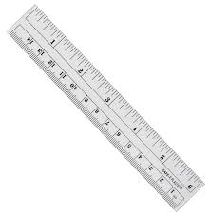 | 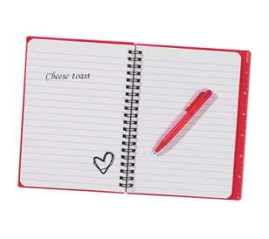
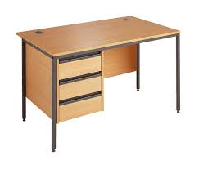
- Odd one out:
- a. pencil b. hello c. hi d. good morning
- a. she b. he c. I d. come
- a. library b. gym c. open d. play ground
- a. notebook b. school bag c. rubber d. ask
- a. stand b. small c. new d. old
- a. go b. come c. sit d. pencil case
- a. classroom b. close c. computer room d. music room
- a. notebook b. school bag c. school d. ruler
- a. come b. nice c. big d. beautiful
- a. pencil case b. pencil c. please d. rubber
- a. pen b. book c. large d. ruler
- a. new b. school c. big d. old
- a. my b. her c. his d. you
- a. friend b. classroom b. school d. gym
- a. are b. those c. is d. am
- Choose the correct answer:
- This is my ............................ (rubbers/ pencils/ notebook)
- Who ............................ that? (is/ are/ am)
- Stand ............................ , please. (down/ here/ up)
- May I ............................ my name here? (sit/ write/ open)
- How ............................ is she? (are/ new/ old)
- Are they your ............................ ? (friend/ friends/ frieds)
- Those are my ............................ (ruler/ rubber/ pencils)
- ............................ are my friends. (the/ this/ those)
- Is the ............................ new? (small/ classroom/ new)
- ............................ your book, please. (ask/ open/ write)
- ............................ are my books. (these/ the/ that)
- That is my ............................ . (pencils/ pencil sharpener/ pens)
- My classroom ............................ big but old. (is/ are/ am)
- This is my ............................ . (cases/ new/ desk)
- Look ............................ the gym. It’s very nice. (in/ at/ to)
- Put the words in correct order:
- school/ my/ are/ these/ things/.
- new/ are/ friends/ those/ my/.
- pens/ are/ these/ pencil/ and/ cases/ my/.
- bag/ school/ my/ is/ this/.
- shool/ big/ nice/ and/ my/ is/.
- old/ is/ she/ how/?
- is/ this/ my/ class room/.
- is/ but/ nice/ small/ classroom/ my/.
- books/ too/ new/ notebooks/ my/ are/ and/.
- is/ desk/ my/ this/.
- Mai’s/ is/ pen/ this/.
- Peter’s/ those/ rubbers/ are/.
- 3a/ am/ in/ class/ I /.
- old/ too/ seven/ years/ is/ she/.
- music/ is/ room/ that/ the/.
- Translate into English:
- Bàn học |  | - Cục tẩy
- Gọt bút chì |  | - Bút mực
- Phòng thể dục |  | - Thước kẻ
- Bao nhiêu tuổi |  | - Bút chì
- Mới |  | - Cặp sách
- Cũ |  | - Sách
- Rộng lớn |  | - Vở
- Phòng học |  | - Những cái kia
- Những cái này |  | - Gì, cái gì
- Đồ dùng học tập |  | - Ai, người nào
- Read and choose True (đúng) or False (sai):
This is my classroom. It is big. This is my school bag. It is new. That is my pencil sharpener. It is small. These are my pencils. They are short (ngắn). Those are my books. They are new.
 | True | False
- The classroom is big.
- The pencil sharpener is small.
- The pencils are long.
- The books are old.
- The school bag is old too.

UNIT 9. WHAT COLOUR IS IT?
(Test 2)
Ex 1: Put the words in correct column (Cho các từ dưới đây vào cột thích hợp):
Black, one, stand, classroom, notebook, ask, gym, rubber, three, brown, ruler, music room, open, nine, white, sit, pencil sharpener, eight, red, pen, green, library, playground, eleven, close, orange, twelve, computer room, desk, write
Colour | School thing | School facility | Number | Action

Ex 2: Odd one out:

- a. black b. colour c. green d. purple
- a. sit b. stand c. ask d. these
- a. down b. this c. that d. these
- a. what b. how old c. hello d. who
- a. friend b. go c. come d. stand
- a. eight b. black c. white d. yellow
- a. come b. brown c. close d. open
- a. blue b. brown c. green d. book
- a. what b. white c. who d. how
- a. two b. four c. nine d. five
- a. out b. can c. in d. here
- a. his b. your c. I d. her
- a. she b. they c. my d. he
- a. it b. those c. these d. they
- a. rubber b. pencil c. orange d. pencil case
- a. school b. school bag c. desk d. pencil
- a. hello b. hi c. sharpener d. goodnight
- a. books b. notebooks c. ruler d. rubbers
- a. pens b. notebook c. pencil d. pencil case
- a. big b. year c. old d. large

Ex 3: Choose the correct answer (Chọn đáp án đúng):
- They are my ............... . (friend/ pens/ ruler/ rubber)
- ............... is my bookcase. ( they/ those/ these/ it)
- Those ............... my pencils. (is/ am/ are/ do)
- What colour ............... your book, Nam? ( is/ am/ are/ do)
- What colour ............... your pens? (is/ am/ are/ do)
- Is ............... your desk? (those/ these/ that/ they)
- What colour ............... they? (is/ am/ are/ do)
- The bookcase is ............... . (seven/ colour/ orange/ not)
- ............... are her pencil case. (this/ that/ those/ it)
- Is the gym ............... ? (stand/ large/ sit/ come)
- May I ............... down? (stand/ come/ ask/ sit)
- ............... to meet you. (nine/ nice/ night/ ny)
- How do you spell ............... name? ( you/ your/ they/ she)
- May I go out? – no, you ............... . (can/ aren’t/ isn’t/ can't)
- How old are you? - ............... . (fine, thanks/ I’m fine, thanks/ I'm nine/ thank you)
- My school is big and ............... . (stand/ new/ up/ sit)
- The ............... are blue. (pen/ pencil/ bookcase/ rulers)
- ............... is my notebook. (They/ she/ he/ it)
- What ............... are her book? – They are brown. (old/ this/ that/ colour)
- Are they your ............... ? (friend/ pen/ pencil/ friends)

Ex 4: Read and answer the questions (Đọc và trả lời các câu hỏi bên dưới):
Hello, I’m Linh. I’m eight years old. I’m in class 3a4 at Quang Trung Primary School. My school is big and new. My class is big and new, too. This is my desk. It is brown. These are my books. They are yellow. This is my notebook. It’s pink. These are my pens. They are black and white. This is my rubber. It’s orange and white. And this is my school bag. It’s blue, green and red. What about you? What colour are your school things?
- What’s her name?
- How old is she?
- Is her school big and new?
- What colour is her desk?
- What colour is her school bag?
- What colour are her books?
- What colour are her pens?
- Is her rubber red?

Ex 5: Read and match (Đọc và nối)
- What colour are your rubbers? | - It’s black and brown.
- How old is he? | - It’s big.
- Are those her rulers? | - No, it isn’t.
- May I come in, sir? | - Her name is Lan Anh.
- What colour is your school bag? | - He’s ten.
- What’s her name? | - Yes, they are.
- Is your classroom big or small? | - Yes, you can.
- Is this your desk? | - They are green and white.

Ex 6: Translate in to English (Dịch sang tiếng Anh):
- Hộp bút của bạn màu gì? – Nó màu xanh da trời và trắng.

- Những chiếc bút chì của bạn màu gì? – Chúng màu vàng.

- Đây là những quyển sách của tôi. Chúng màu xanh lá cây.

- Thư viện có rộng và đẹp không? – Có.

- Kia là bàn học của tớ. Nó màu nâu.

- Kia là những chiếc bút của tớ?

- Chúng màu gì? – Chúng màu đen và nâu.

- Đây có phải gọt bút chì của bạn không? – Không phải.

- Đây là những cục tẩy của tớ.

- Lớp học của tớ màu hồng và trắng,.

UNIT 10. WHAT DO YOU DO AT BREAK TIME?
(Test 1)
Bài 1: Gạch chân từ không cùng nhóm với các từ còn lại:
- Fine nice five big
- He she I my
- Meet miss stand sit
- Book ruler rubber gym
- What who hello how
Bài 2: cho từ trái nghĩa với các từ sau:
Big |  | Sit
New |  | Come in
Black |  | This
Open |  | These
Up |  | She
Bài 3: hoàn thành bảng sau:
Số ít | Số nhiều | Số ít | Số nhiều
book |  | is
 | notebooks |  | School bags
 | rubbers | pencil
this |  | sharpener
 | those |  | pens
Bài 4: Sắp xếp các từ sau vào cột sao cho thích hợp:
Football, gym, desk, white, orange, rubber, badminton, skipping, skating, library, classroom, pencil, pencil case, basketball, computer room, black, blue, green
Games | School thing | School facility | Colour
Bài 5 : hoàn thành bảng sau
English | Vietnamese | English | Vietnamese
 | Cầu lông |  | Bóng rổ
 | Bóng đá | They
Like |  | are
Play |  |  | Giờ giải lao
 | Nhảy dây | Skating
Bài 6: viết 10 câu khác nhau để trả lời câu hỏi sau:
What do you do at break time?

UNIT 11. THIS IS MY FAMILY
(Test 1)
Ex 1: Read and match:
- Father | - Con trai
- Granfather | - Gia đình
- Daughter | - Chị, em gái
- Grandmother | - Người đàn ông
- Son | - Con gái
- Sister | - Anh, em trai
- Mother | - Nhỏ nhắn, bé nhỏ
- Brother | - Bố, cha
- Family | - Bà
- Man | - Bức ảnh
- Little | - Má, mẹ
- Photo | - Người phụ nữ
- Woman | - Ông
Ex 2: Odd one out:
- a. father b. mother c. rubber d. sister
- a. ruler b. grandfather c. grandmother d. brother
- a. black b. brown c. blue d. brother
- a. small b. school bag c. young d. little
- a. photo b. stand c. it d. ask
- a. how old b. nice c. what d. who
- a. am b. hello c. is d. are
- a. my b. her c. his d. he
- a. your b. bookcase c. desk d. pencil shapener
- a. classroom b. computeroom c. new d. gym

Ex 3: Write the number below in English:
1: one | 9: nine | 17: seventeen | 70: seventy
2: two | 10: ten | 18: eighteen | 80: eighty
3: three | 11: eleven | 19: nineteen | 90: ninety
4: four | 12: twelve | 20: twenty | 100: one hundred
5: five | 13: thirteen | 30: thirty | NUMBER
6: six | 14: fourteen | 40: forty
7: seven | 15: fifteen | 50: fifty
8: eight | 16: sixteen | 60: sixty

15 |  | 63
21 |  | 67
25 |  | 78
34 |  | 88
36 |  | 93
42 |  | 94
49 |  | 95
55 |  | 99

Ex 4: Transalte into English:
- Kia là ai?
- Đây là ai?
- Đây là ông của tôi.
- Đây là bà của tôi.
- Đây là bố của tôi.
- Đây là mẹ của tôi.
- Đây là chị gái của tôi.
- Đây là em trai của tôi.
- Đây là con gái của tôi.
- Đây là con trai của tôi.
- Người đàn ông đó là ông của cô ấy.
- Người phụ nữ đó là bà của cô ấy.
- Người đàn ông đó là bố của cô ấy.
- Người phụ nữ đó là mẹ của cô ấy.
- Cô gái đó là chị gái của cô ấy.
- Cậu bé đó là em trai của cô ấy.
- Ông của tôi 70 tuổi.
- Bà của tôi 68 tuổi.
- Bố của tôi 45 tuổi.
- Mẹ của tôi 43 tuổi.
- Chị gái của tôi 22 tuổi.
- Em trai của tôi 11 tuổi.
- Tôi 13 tuổi.
- Bố của bạn bao nhiêu tuổi?
- Mẹ của bạn bao nhiêu tuổi?
- Chị gái của bạn bao nhiêu tuổi?
- Em trai của bạn bao nhiêu tuôi?
- Anh ấy là bạn của tôi, Nam.
- Cô ấy là em gái của tôi.
- Đây là em trai của tôi.

Ex 5: Answer questions about you:
- What’s your name?
- How are you?
- How old are you?
- What colour is your school bag?
- What colour is your pen?
- How old is your father?
- How old is your mother?
- How old is your brother/ sister?
- Circle the odd one out:
- A. mother B. father C. uncle D. brother
- A. grandfather B. brother C. grandmother D. teacher
- A. sister B. brother C. friend D. mother
- A. family B. Mummy C. Baby D. Daddy
- A. daughter B. uncle C. son D. baby
- A. house B. bedroom C. garage D. kitchen
- A. bathroom B. school C. bedroom D. dining room
- A. kitchen B. dining room C. library D. living room
- A. class room B. bathroom C. living room D. bedroom
- A. table B. chair C. garden D. desk
- Look at the letters, write the words:
- souhe |  | - fefetni
- ngerad |  | - welvet
- thiknec |  | - teghi
- redbomo |  | - wetnyt
- tohobram |  | - leneve
III. Ask and answer questions about these people’s age:
- Lee/ 5

- Ben/ 15

- Pat/ 13

- May/ 12

- Kim/ 2

- Tiffany/ 20

IV. Read the text carefully then answer the questions below:
My name is Tony. I am nine years old. I am in the picture with my relative. This is my uncle Tim. He is twenty nine years old. This is my aunt Tina. She is twenty-eight years old. This is my cousin Pat. He is thirteen years old. This is my cousin Jill. She is three years old. I like to play with Pat and Jill.
- How old is Tony?
- How old is uncle Tim?
- How old is aunt Tina?
- How old is Pat?
- How old is Jill?
V. Reorder these words to make meaningful sentences:
- Small/ is/ this/ house/ a/.
- a/ living/ large/ room/ is/ this.
- There/ is/ in/ house/ the/ bedroom/ a/ ?
- Pond/ in/ garden/ the/ is/ a/ there/.
- Kitchen/ the/ old/ is/.
- Room/ living/ the/ large/ is/.
- Bath/ the/ room/ big/ is/.
- That/ a/ is/ pond/.
- Over/ there/ the/ is/ garden/.
- My/ is/ this/ house/. / is/ it/ beautiful/.
VI. Read and tick (v)
Hi! My name is Lan. This is my house. It is big. There is a garden in front of the house. There are trees in the garden. There is not a garage. The living room is large ,but the kitchen small. There are four bedrooms, two bathrooms in my house. There is a pond behind the house. Around the pond, there are many trees and flowers. They are very beautiful.
 | Yes | No
- Lan’s house is small.
- The garden is behind the house.
- The living room is large.
- There are many rooms in Lan's house.
- There is a pond in front of her house.
VII. Translate into English:
- Tớ thích chơi bịt mắt bắt dê.

- Ông của bạn bao nhiêu tuổi?

- Ông của tớ 78 tuổi.

- Đây là phòng khách.

- Nó rất đẹp!

- Có một phòng bếp trong nhà bạn đúng không? – Đúng vậy.

- Đây là một bức ảnh của gia đình tớ.

- Đây là em trai của tớ. Cô bé đứng cạnh cậu ấy là em gái tớ.

- Em gái của tớ 6 tuổi.

- Có một cái ao ở phía trước ngôi nhà của tớ.

UNIT 13. WHERE’S MY BOOK?
(Test 3)
Ex 1: Fill in the gap with a suitable letter:
- D__n__ng room | - __ate | - P__ste__ | - Ne__r
- __athroom | - Y__rd | - __ha__r | - __nder
- Ga__d__n | - T__ee | - B__ll | - Be__ind
- F__nc__ | - __itc__en | - __oat | - P__ctur__
Ex 2: Put the words in correct order:
- is/ coat/ my/ where/? // - on/ wall/ it/ is/ the/.

- balls/ his/ where/ are/? //– are/ they/ under/ chair/ the/.

- is/ of/ in/ there/ a / tree/ house/ my/ front/.

- is/ fence/ around/ there/ a/ house/ her/.

- bed/ the/ is/ where/ ?// – is/ in/ it/ bedroom/ the/.

- is/ gate/ front/ in/ of/ there/ a/ house/ my/.

- seventy/ grandfather/ is/ years/ my/ old/.

- a/ is/ living room/ there/ in/ house/ my/.

- cat/ a/ the/ chair/ is/ behind/there/.

- are/ four/ chairs/ near/ table/ the/ there/.

Ex 3: Read and match:
- Where’s the bed? | - They are on the wall.
- What colour is your coat? | - No. But there is a big tree.
- How old is your mother? | - They are in your schoolbag.
- How old are you? | - I’m fine, thanks.
- Where are my books? | - It’s brown.
- Is there a pond in front of your house? | - It’s in the bedroom.
- How are you? | - I’m nine years old.
- Where are his posters? | - She’s thirty eight years old.
Ex 4: Translate into English:
- Tấm áp phích ở đâu?
- Cái giường ở đâu?
- Cái ghế ở đâu?
- Những quyển sách của tớ ở đâu?
- Chiếc áo khoác của cô ấy ở đâu?
- Có một cái áo phía trước ngôi nhà của tôi.

- Những quả bóng ở dưới chiếc bàn.

- Có 1 phòng khách và 4 phòng ngủ trong nhà của tôi.

- Những quyển vở và những chiếc bút chì của tôi ở trên bàn học.

- Khu vườn ở đằng kia. Nó rất đẹp.

Ex 5: Read and match:
- 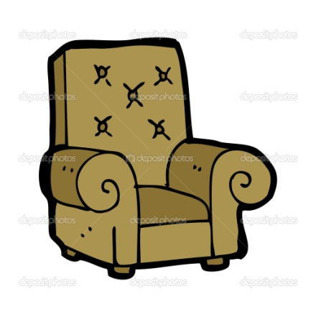
- 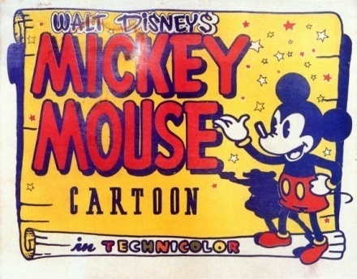 |  | - 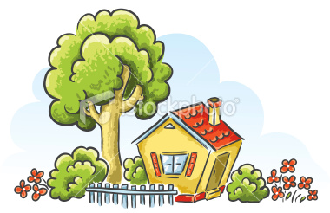
- There’s a bed in the bedroom. |  | - There’s a chair. |  | - There’s a poster.
- There’s a big tree near my house. |  | - The coat is brown. |  | - It’s a nice ball.
Ex 6: Look and write:
Hello, my name is Phuong. This isa picture of my (1) ........................................ . There are (2)........................................ people in my family. They are: my (3) ........................................ , my (2) ........................................ , my (4) ........................................ , my (5) ........................................ , my (6) ........................................ and me, Phuong. My grandfather is 65 (7) ........................................ old. My (8) ........................................ is 60 years old. They are not young. They are old. My father is 45 years old. My (9) ........................................ is 40 years old. I am 8 years old. And my (10) ........................................ is 6 years old.
- People: người
Questions:
- How old is Phuong’s grandfather?
- How old is her father?
- How old is Phuong?
- How old is her brother?
- Are her grandfather and grandmother young?
Ex 7: Odd one out:

- a. book b. brother c. pen d. desk
- a. where b. how c. how old d. old
- a. father b. grandfather c. brother d. sister
- a. fourty b. nice c. eight d. nine
- a. my b. his c. she d. her
- a. ball b. teacher c. mother d. sister
- a. poster b. picture c. kitchen d. book
- a. living room b. bathroom c. bed d. kitchen
- a. hello b. how c. how old d. where
- a. library b. green c. yellow c. black

UNIT 14: ARE THERE ANY POSTERS IN THE ROOM?
(Test 1)
Exercise 1: make sentences using the words given:
Example:
- There/ three/ book/ on/ table. There are three books on the table
- There/ a/ chair/ near/ desk. There is a chair near the desk.
- There/ two/ map/ wall.

- There/ a/ television/ on/ table.

- There/ three/ bedroom/ in/ my house.

- There/ a/ lamp/ on/ table.

- There/ five/ pencil/ in/ pencil box.

- There/ five/ room/ in/ my house.

- There/ twenty/ student/ in/ my class.

- There/ two/ door/ a/ window/ in/ my room.

- There/ eight/ chair/ a/ sofa/ a/ desk/ in/ living room.

- There/ nine/ coat/ in/ wardrobe.

Exercise 2: make and answer the questions:
Example:
- there/ book/ in/ schoolbag/ ? / Yes Are there any books in the schoolbag? – Yes, there are.
- there / sofa/ in/ living room/ ? / No Are there any sofas in the living room? – No, there aren’t.
- There/ wardrobe/ in/ bedroom/ ? / No

- There/ cupboard/ in/ dining room/ ? / No

- There/ picture/ in/ bedroom/ ? / Yes

- There/ lamp/ on/ table/ ? / Yes

- There/ bed/ in/ kitchen/ ? / No

- There/ student/ in/ school/ ? / Yes

- There/ coat/ in/ wardrobe/ ? / Yes

Exercise 3: make and answer the questions:
Example:
- Cupboard/ in/ kitchen/ ? / 1 How many cupboards are there in the kitchen? – There is one.
- Student/ in/ class/ ?/ 30 How many students are there in the class? – There are thirty.
- Coat/ in/ wardrobe/ ? / - 15

- Picture/ on/ wall/ ? / - 4

- Fan/ in/ living room/ ? / - 3

- Window/ in/ bedroom/ ? / - 2

- Chair/ in/ living room/ ? / - 6

Exercise 4: give correct order
- edb |  | - ootph
- otac |  | - ksed
- lalw |  | - rean
- soptre |  | - irahc
- lalb |  | - irrrom
- afos |  | - icpuret
- oardpuc |  | - pam
- oodr |  | - mpal
- naf |  | - nwiowd

Exercise 5: Read and answer the questions:
This is my living room. There are many things in the room. There are three windows and one door. There is a sofa, a desk, six chairs. There is two lamps on the desk and a TV on the cupboard. There are five pictures and one fan on the wall.
- How many windows are there?
- How many chairs are there?
- How many pictures are there?
- How many fans are there?

Exercise 6: Write a paragraph to describe your bedroom:

REVIEW UNIT 14, 15
Exercise 1: Odd one out:

- A. school b. bathroom c. bedroom
- A. kitchen b. dining room c. library
- A. classroom b. bathroom c. living room
- A. table b. chair c. garden
- A. door b. bed c. window
- A. map b. sofa c. poster
- A. sofa b. chair c. desk
- A. cupboard b. window c. cupboard
- A. door b. mirror c. window
- A. doll b. school c. ball
- A. kite b. car c. fan
- A. yo-yo b. plane c. computer room
- A. ship b. fence c. plane
- A. gate b. robot c. yard
- A. sister b. woman c. boy
- A. livingroom b. kitchen c. school
- A. ruler b. behind c. in front of
- A. mother b. teacher c. brother
- A. fence b. pond c. your
- A. chair b. table c. desk
Exercise 2: Fill in the blank with is, are, have or has:
- There .............................. a poster on the wall.
- .............................. they your friends?
- Where .............................. my books?
- I .............................. an eraser and five pencils.
- She .............................. many pretty dolls.
- Does she .............................. any toys? – No, she doesn’t.
- Hello, my name is Lan. This .............................. my friend, Hoa.
- Are there any pictures on the desks? – No, there .............................. not.
- How many people .............................. there in your family? – There .............................. four people.
- There .............................. a pond in my garden.
Exercise 3: Make sentences using “how many”
Example: room/ in/ your house? – 7 How many rooms are there in your house? – There are seven.
- Doll/ on/ the shelf? – 5

- Living room/ in/ your house? – 1

- Teddy bear/ on/ the table? – 2

- Coat/ in/ the wardrobe? – 8

- Bed/ in/the bedroom? – 2

Exercise 4: Make sentences using “Do/ Does…have…? - …have/ has…”
Example:
- She/ doll? –2 Does she have any dolls? – She has two dolls.
- You/ cup?- 6 Do you have any cups? – I have six cups.
- You/ teddy bear? – 3

- Your mother/ coat? – 4

- He/ ball? – 1

- Lan and Hoa/ doll? – 5

- Nam/ car? – 7

- Your brother/ robot? – 2

- Your father/ map? – 3

- You/ toy? – 8

Exercise 5: Give correct order to make meaningful sentences:
- Ball/ the/ is/ the/ bed/ on

- There/ bedroom/ in/ the/ is/ chair

- The/ behind/ desk/ chair/ the/ is

- Are/ there/ balls/ two/ the/ table/ near

- Garden/ pond/ the/ the/ in/ is

- sister/ eight/ old/ years/ my/ is

- five/ in/ there/ are/ rooms/ house/ my

- big/ tree/ there/ is/ next/ my/ to/ house/ a

- books/ my/ my/ school bag/ are/ in/

- old/ your/ is/ how/ grandfather/?

Exercise 6: Fill in the blank with suitable word:
Shelf – window – chairs – table – bed
Look at my bedroom. It is large and nice. There are many things in my bedroom. Here is my (1) .............................. . the bed is big. Next to the bed is a big (2) .............................. . My school things are on this table. There are two small (3) .............................. behind the table. There is a (4) .............................. near my bed. My balls and robots are on this shelf. There is a beautiful picture above (phía trên) the (5) .............................. .
Exercise 7: Translate into English:
- Có tám phòng trong nhà của tôi.

- Bà của tôi 65 tuổi.

- Có một cái ao ở phía trước nhà của tôi.

- Những tấm bản đồ ở trên tường.

- Có bao nhiêu phòng trong nhà của bạn?

- Có 13 phòng trong nhà của cô ấy.

- Có một tấm áp phích ở trên tường.

- Có ba quyển sách ở trên bàn học.

- Những chiếc áo khoác ở đâu? – chúng ở trên ghế.

- Có bao nhiêu cửa sổ ở trong nhà bạn? – Có 6 cửa sổ.

UNIT 16. DO YOU HAVE ANY PETS?
(Test 1)
EXERCISE 1: Fill in the blank with DO, DOES, HAVE, HAS:
- ..................................... you like English? – Yes, I ..................................... .
- She ..................................... a cat. Its name is Mimi.
- ..................................... Lan play football? – No, she ..................................... not.
- ..................................... Mai and Hoa have any dolls? – Yes, they ..................................... . They ..................................... many beautiful dolls.
- My house ..................................... many rooms: living room, dining room, kitchen, bathroom and bedroom.
- Mr. Tuan ..................................... a dog.
- I ..................................... a parrot and a turtle.
- Lan, Nga and Hoa ..................................... many pictures.
- ..................................... they have any posters? – Yes, they ..................................... .
- ..................................... he have any cats? – yes, he ..................................... .
EXERCISE 2: Make questions using the following cues:
- You/ have/ cat? – no/ 2/ dog.

- She/ have/ parrot? – yes/ 1.

- Your grandmother/ have/ cat? – yes/ 3.

- You/ have/ goldfish? – no/ 5 / tortoise.

- He/ have/ rabbit? – yes/ 6.

EXERCISE 3: Read and write:
Hi! My name is Nga. I have a lot of pets. This is my cats. They are on the chair. That is my dog. It is under the table. I also have many goldfishes. They are in the fish tank. They are very cute. I also have two parrots and five rabbits. They are in the garden.
- Nga has ..................................... of pets.
- She has a ..................................... . It is ..................................... the table.
- She has many ..................................... . They are ..................................... fish tank.
- She also have ..................................... and ..................................... . They are in the ..................................... .
EXERCISE 4: Make questions using the following cues:
- Where/ cats? – they/ in front of/ the TV.

- Where/ dog? – it/ under/ the table.

- Where/ parrot? – it/ in/ the cage.

- Where / gold fish? – it/ in / the fish tank

- Where/ rabbits? – they/ in/ the garden.

UNIT 17. TEST 1
I. Circle the odd one out
1. puzzle kite car bread
2. globe map door board
3. forty study twenty fifty
4. purple puddle brown orange
5. TV doll toy kite
II.Choose the best answer
- (Where /What /Who ) is the book? On the table
- (There /These /This) bicycle is pink.
- (Is /Are / Do) you eight years old ?Yes, I (are / is / am).
- This is a (table round / a round table / round table ).
- (What /Where /Who) is this ?Mr Brown.
- Tony is (reading / flying / eating ) a kite.
- How many dolls (are /is /am ) there in the box ?
- (Are /Do /Is ) she pretty? Yes,she is.
- Those are our (a schoolbag/ schoolbag /schoolbags)
- What is his name? (He / His / It )is Phong.
III. Fill in the missing letters.
1. m…p 6.bi…ycle
2. br….wn 7.ci….cle
3. c…r 8. ra…bit
4. flo…er 9. un…er
5. po…ter 10. boa…d
IV. Make questions for the answers
- …………………………………………?It’s a poster.
- ………………………………………….?She is nine years old.
- ………………………………………….?fine, thank you.
- ………………………………………….?Yes, he can.
- …………………………………………..? It’s pink and black
- ……………………………………………?He’s my father.
- …………………………………………….? I’m from Australia
- ……………………………………………..?They are playing football.
- ……………………………………………..? No, it isn’t.
- ………………………………………………?My name is BEAKIE.
V. Translate into Vietnamese.
1.Those are our new schoolbags.
2. Is this an orange rectangle?
3. I can sing but I can’t dance.
Unit 18: What are you doing?
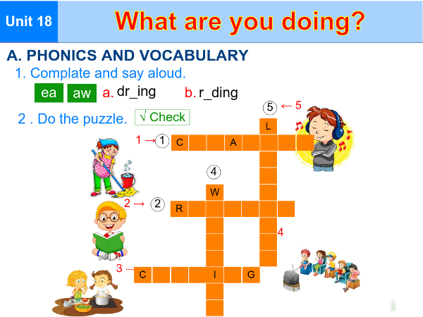
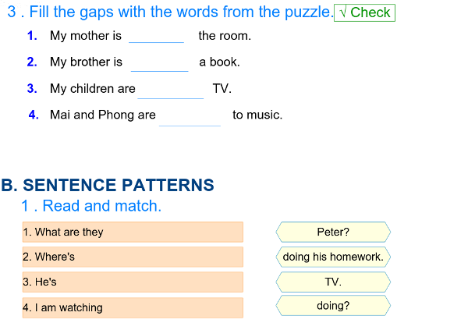
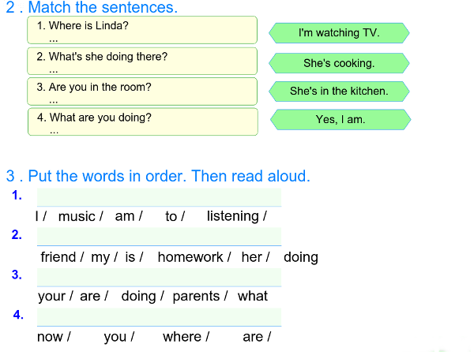
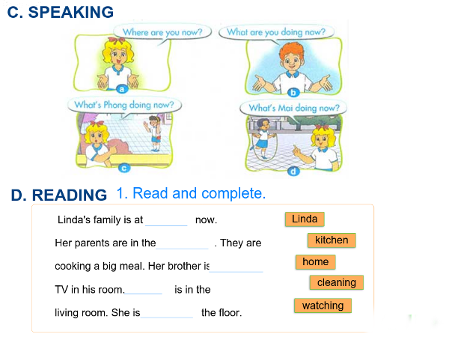
Unit 19: They are in the park
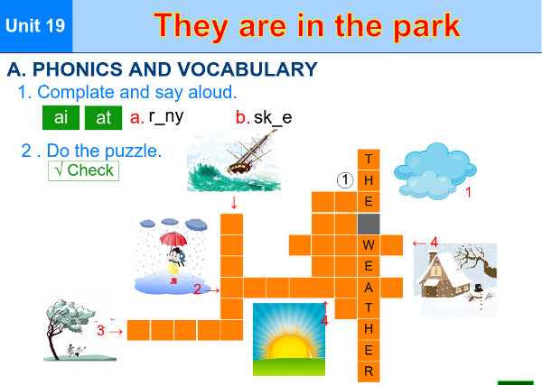
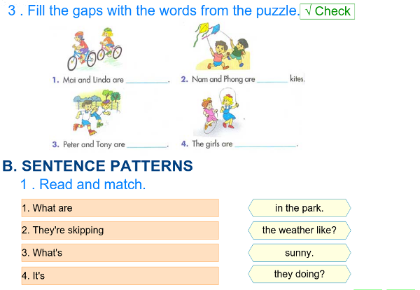
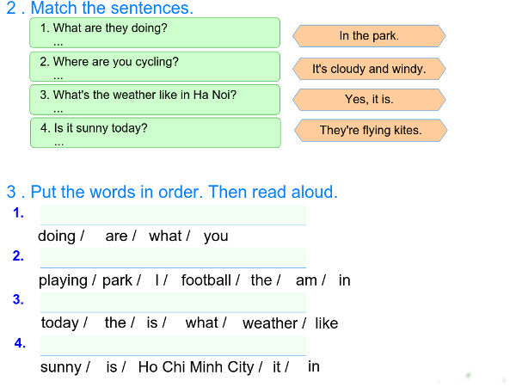
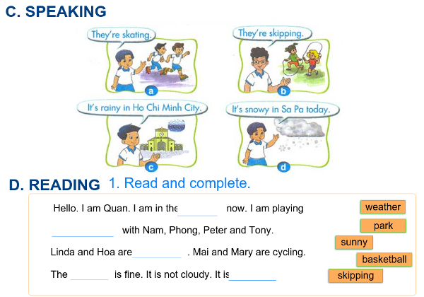
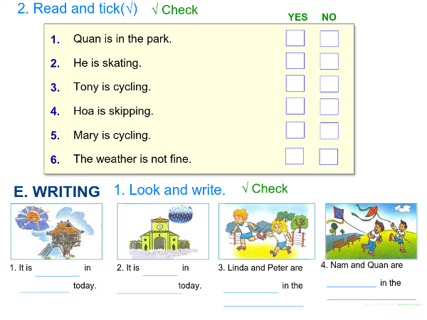
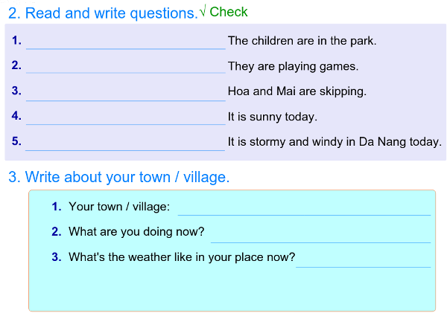
Unit 20: Where is Sa Pa?